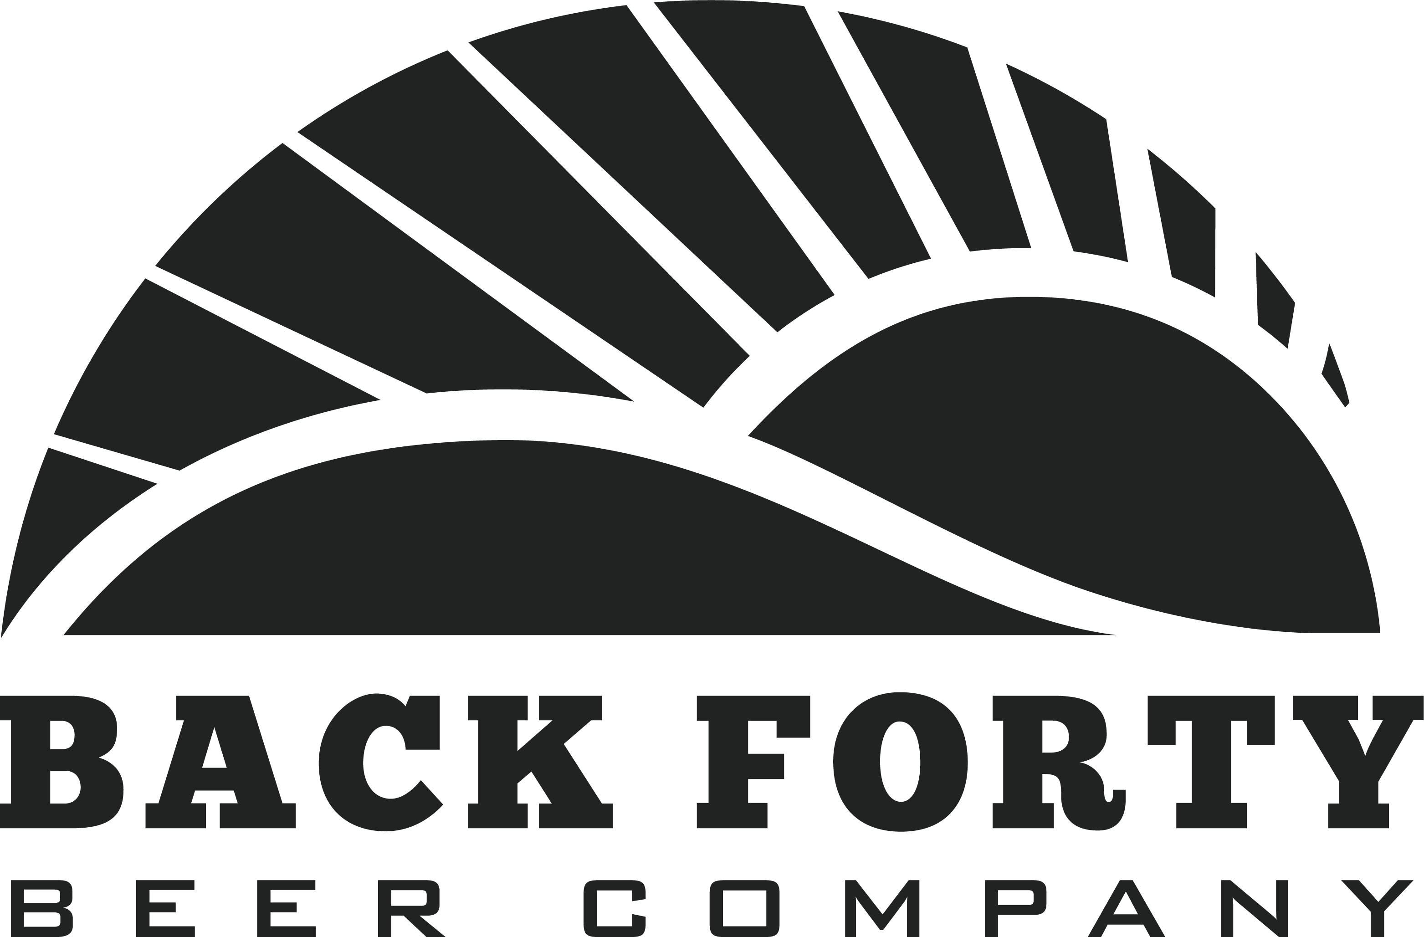

Sponsorship Request Form

Event:
Event Date:
Event Duration:
Event Location:
Expected Attendance:
Organization:

Contact:
Phone:
Fax:
Email:

Sponsorship Request:

Audience Profile (age, gender, income, geographic draw, etc):

Marketing Opportunities (advertising, flyers/posters, publicity, site signage, website, etc):

In cases where Back Forty Beer will be served, describe the nature of the bar service (bottles/draft, cash/host bar, beer only, wine and beer, full bar, etc):

How much product will you require (estimate approximately one drink per person):

*Back Forty cash sponsorship and marketing budgets are determined on an annual basis at the beginning of each fiscal year. Please submit all cash sponsorship requests at least 12 months before your event for consideration. Alabama state law requires all beer donations be allocated to licensed events. To secure a special events license for your event, please contact your local ABC enforcement office. Please email this form to Brad Wilson at brad@backfortybeer.com. Cheers!

